Haul-out behavior and aerial survey detectability of seals in the Bering and Chukchi seas

Josh M. London1,✉, Paul B. Conn1, Stacie K. Hardy1, Erin L. Richmond1, Jay M. Ver Hoef1, Michael F. Cameron1, and Peter L. Boveng1

1 Marine Mammal Laboratory, Alaska Fisheries Science Center, NOAA Fisheries, Seattle, Washington, USA

✉ Correspondence: [Josh M. London <[josh.london@noaa.gov](mailto:josh.london@noaa.gov)>](mailto:josh.london@noaa.gov)

## Abstract

Ice-associated seals rely on sea ice for a variety of activities, including breeding, molting, pupping, and resting. In the Arctic, many of these activities occur in spring (April-June) as sea ice begins to melt and retreat northward. Rapid acceleration of climate change in Arctic ecosystems is therefore of concern as the quantity and quality of suitable habitat is forecast to decrease. In this paper, we use data collected from satellite-linked bio-loggers deployed between 2005 and 2020 to investigate the seasonal timing and environmental factors affecting sea ice use by seals (specifically, bearded, ribbon, and spotted seals) in the Bering and Chukchi seas. In addition to providing baseline data on phenology, these data also allow us to quantify ‘availability’, which is needed to accurately estimate abundance from aerial survey counts of seals basking on ice (i.e., to correct for the proportion of animals that are in the water while surveys are conducted). Using generalized linear mixed pseudo-models to properly account for temporal autocorrelation, we fit models with a variety of covariates (e.g., day-of-year, solar hour, age-sex class, wind speed, barometric pressure, temperature, precipitation) to examine their ability to explain variation in hourly haul-out records. We found evidence for strong diurnal and within-season patterns in haul-out behavior, as well as strong weather effects (particularly wind and temperature). In general, seals were more likely to rest on ice in the middle of the day and when wind speed was low and temperatures were higher. Haul-out propensity increased through March and April, peaking in May and early June before declining again. The timing and frequency of haul-out events also varied based on species and age-sex class. For ribbon and spotted seals, models with year effects were highly supported, indicating that the timing and magnitude of haul-out behavior varied among years. However, we did not find evidence that haul-out timing was linked to annual sea ice extent. Our analysis emphasizes the importance of accounting for variation in haul-out behavior when interpreting the number of seals counted in aerial surveys.

keywords: availability; generalized linear mixed pseudo-model; haul-out behavior; phenology; Phocidae; sea ice

# Introduction

The global climate disruption is causing considerable reduction in Arctic sea ice extent, volume, and seasonal presence [3]. These changes have ripple effects on Arctic organisms, ecosystems, and the human communities who live in the region [4]. Such disruptions are a particular cause of concern for ice-associated seals (ringed (*Pusa hispida*), bearded (*Erignathus barbatus*), spotted (*Phoca largha*), and ribbon seals (*Histriophoca fasciata*)) that depend on spring and early summer sea ice (March-June) in the Bering and Chukchi seas as a platform for important functions, such as pupping, nursing, breeding, and molting [5–8]. Limited data and large knowledge gaps complicate predictions about the ultimate effects of changes in sea ice on the behavior, abundance, and distribution of these seals. Knowledge about evolutionary constraints on the timing of reproductive and molting behavior is generally lacking, so it is difficult to predict the readiness with which ice-associated seal species will be able to adapt to future changes (e.g., by adjusting pupping or molting schedules to earlier dates or different locales). Additionally, trends in abundance of these species are largely unknown, so it is difficult to say what effect, if any, declines in sea ice habitat have had, or will have, on seal densities.

For ice-associated seals, haul out is tightly linked with sea ice. Ribbon seals rest out of the water almost exclusively on sea ice and are mostly pelagic outside the spring pupping, breeding, and molting season [9]. While spotted and bearded seals rest on beaches during ice-free months, they strongly prefer sea ice as a resting platform during the spring and early summer [10]. The remoteness of the Bering and Chukchi seas mean direct scientific observation of seal behavior is impractical. Bio-logging devices are, thus, especially useful tools for collecting key information on movement and haul-out behavior for these species.

Bio-logging records of time spent out of the water provide valuable data for identifying covariates that explain variation in haul-out behavior. For instance, in the Antarctic, Bengtson and Cameron [11] relied on bio-logging data to demonstrate greater haul-out propensity in juvenile crabeater seals (*Lobodon carcinophaga*) than adults, with highest probabilities in February and at times close to solar noon. In the Arctic, Von Duyke et al. [12] used seal-borne, satellite-linked loggers to corroborate seasonal changes between diurnal and nocturnal haul-out behavior of ringed seals previously described by Kelly et al. [8] using labor-intensive VHF radio tags and direct observation. Bengtson et al. [13] documented a higher propensity for ringed seal basking near solar noon, as did Ver Hoef et al. [14] in an analysis of bearded, ribbon, and spotted seals using much larger sample sizes. Olnes et al. [15] showed that the proportion of time bearded seals spent hauled out progressively increased through spring and summer. And, Ver Hoef et al. [14] found haul-out probabilities increased gradually starting in March and peaking in May and June for bearded, ribbon, and spotted seals.

While bio-logging of haul-out patterns clearly has utility for description of ice-associated seals’ natural history and ecology, some studies have focused, as we do here, specifically on quantifying the probability of seals being hauled out as a means of accounting for seals in the water, and therefore missed, during aerial surveys. These studies typically use logistic regression-style analyses to estimate the time-specific probability of being hauled out base on ‘wet/dry’ data relayed by bio-loggers. In these models, haul-out probabilities were expressed as a function of predictive covariates, such as time of day, day-of-year, sex, age class, and environmental conditions (e.g., [16], [11], [13], [17], [14], and [18]). However, sample sizes have often been low and insufficient to permit strong inference about life history and/or seasonal variation in haul-out probabilities. For instance, Bengtson and Cameron’s [11] study included 5 adult and 2 juvenile crabeater seals, while Bengtson et al.’s [13] study was based on 6 telemetered ringed seals in the Chukchi Sea. These studies were often further limited by logistical constraints on tagging fieldwork and the attachment duration or operational life of satellite tags. In this study, we address some of these limitations by deploying small bio-loggers designed for attachment on a portion of the study individuals. These devices are designed to collect data through the molt period (when those adhered to the hair would fall off) and, in some situations, provide multiple years of data.

Ultimately, knowledge of trends in phenology and abundance (or life history surrogates such as survival and recruitment) will be necessary to make credible quantitative predictions about the effects of the climate crisis on the abundance and distribution of Arctic seal populations. Before we can construct a trend, however, we first require a baseline. Several studies have contributed estimates of the distribution and abundance of ice-associated seal species in the Arctic using aerial surveys (e.g., [13], [19], and [14]). Such studies were conducted over very large areas and estimation of absolute abundance required making inference about numerous nuisance processes affecting the observation of seals on ice. This included availability (only seals basking on ice were available to be counted), detection probability (observers or automated detection systems may have missed some seals on ice), species misclassification, and possible disturbance of seals by aircraft [14,19].

In this study, we used data from 15 years of bio-logger records in a comprehensive investigation of haul-out behavior by 3 species of ice-associated seals in the Bering and Chukchi seas. We focused our effort on bearded, spotted, and ribbon seals and did not include ringed seals in the analysis. Ringed seals are unique in their use of snow lairs in the spring months, and they warrant a separate study that includes additional environmental covariates, such as the onset of snow melt and snow depth. Our goals are threefold. First, we wish to establish baseline estimates for the chronology of haul-out behavior in the critical spring season for each species across different age and sex classes. Second, we wish to refine estimates of haul-out availability corrections for aerial surveys in order to improve estimates of seal abundance. Previously estimated availability correction factors (e.g., [13], [19], and [14]) accounted for variables such as the time-of-day and day-of-year, but did not investigate meteorological variables that have been shown to influence haul-out behavior of walruses [16,17]. Third, we explored the annual variability in haul-out timing and possible linkage to dramatic changes in the availability and extent of seasonal sea ice between 2005 and 2020. Our work extends the scope of previous haul-out analyses, includes the influence of meteorological variability, and investigates the potential impact of a changing icescape on the behavior of these species.

# Methods

## Data collection

Haul-out behavior data from 249 bio-loggers deployed on bearded, spotted, and ribbon seals was filtered to include only records from 1 March to 15 July between 2005 and 2020. Bio-loggers were of the ‘SPLASH’ or ‘SPOT’ family of tags developed by Wildlife Computers (Redmond, Washington, USA) and either adhered to the hair on the seal or attached to the rear flipper inter-digital webbing. The use of bio-loggers adhered to the back or head provide some benefits over flipper mounted devices (e.g. increased satellite transmittal rates, locations at sea) but these are lost during the annual molt, which limits the effective length of haul-out timelines. Additionally, sensors attached to the head or dorsal region are often dry while the seal is at the surface and can slightly bias the percent-dry values recorded by the device. For this study, in cases where both tag types were deployed, percent dry observations from the flipper tag were preferred. Sex and age class (non-dependent *young-of-the-year*, sexually immature *subadults*, and mature *adults*) were determined at the time of deployment by subjective judgement based on length, and pelage characteristics for some species. Field identification of age class can be inexact, particularly when discerning subadults from adults. In the case of ribbon seals, pelage differences between subadults and adults are distinguishable, with subadults often having less defined ribbons. Bearded seal subadults will often have a spotted pattern in the pelage that is not seen in adults. Spotted seal pelage is monomorphic and can not be used to discern age class. Despite these challenges, we feel the age classifications used in this analysis are useful categories in testing for age-related effects on haul-out behavior. Seals determined to be less than one year were classified as young-of-the-year. Subadults are those seals likely greater than one year of age but not yet sexually mature. Adults are likely sexually mature and older than approximately four years. For those tags deployed on young-of-the-year and transmitting into the next year, the age class was advanced to subadult on 1 March of the following year. Table provides a summary of these deployments and data received from them.

Table : Summary of bio-logger deployments across seal species and age classification from 1 March to 15 July. Total seal hours represents the sum of available data across all seals.

|  | | Age Class | | |
| --- | --- | --- | --- | --- |
| Species | Sex | Adult | Subadult | Young-of-the-Year |
| Bearded seal | F | 1 ( 1,776 seal hours) | 16 (21,648 seal hours) |  |
| Bearded seal | M | 2 ( 1,676 seal hours) | 16 (17,232 seal hours) |  |
| Ribbon seal | F | 33 (35,128 seal hours) | 18 (15,984 seal hours) | 13 ( 3,734 seal hours) |
| Ribbon seal | M | 24 (27,465 seal hours) | 19 (13,046 seal hours) | 9 ( 4,275 seal hours) |
| Spotted seal | F | 23 (20,654 seal hours) | 20 (17,542 seal hours) | 11 (13,417 seal hours) |
| Spotted seal | M | 20 (28,360 seal hours) | 21 (17,210 seal hours) | 12 (11,285 seal hours) |

Tags that fall off due to molt or mortality and remain on ice or land can still send data to satellites, and we did not want to include data from these tags in our analyses. As such, end times of each deployment were identified by experts who examined several simultaneous data streams (e.g., tag locations and dive behavior) to determine when tags ceased providing data consistent with seal behavior. Sensor readings outside of these start and end times were discarded prior to analysis. After approximately 9 months, 7 devices deployed on the rear flipper of bearded seals reported implausible sensor data. All data after the first instance of unrealistic values were censored from this analysis. Figure shows a calendar distribution of these data across the study season for each species. Observations are concentrated in the months of May and June due to the timing of deployment (April and May) and the timing of molt (May and June). During molt, seals (and their attached bio-loggers) spend more time out of the water and more data is transmitted. Molt timing also impacts when many deployments end as any tags adhered to the hair will fall off.

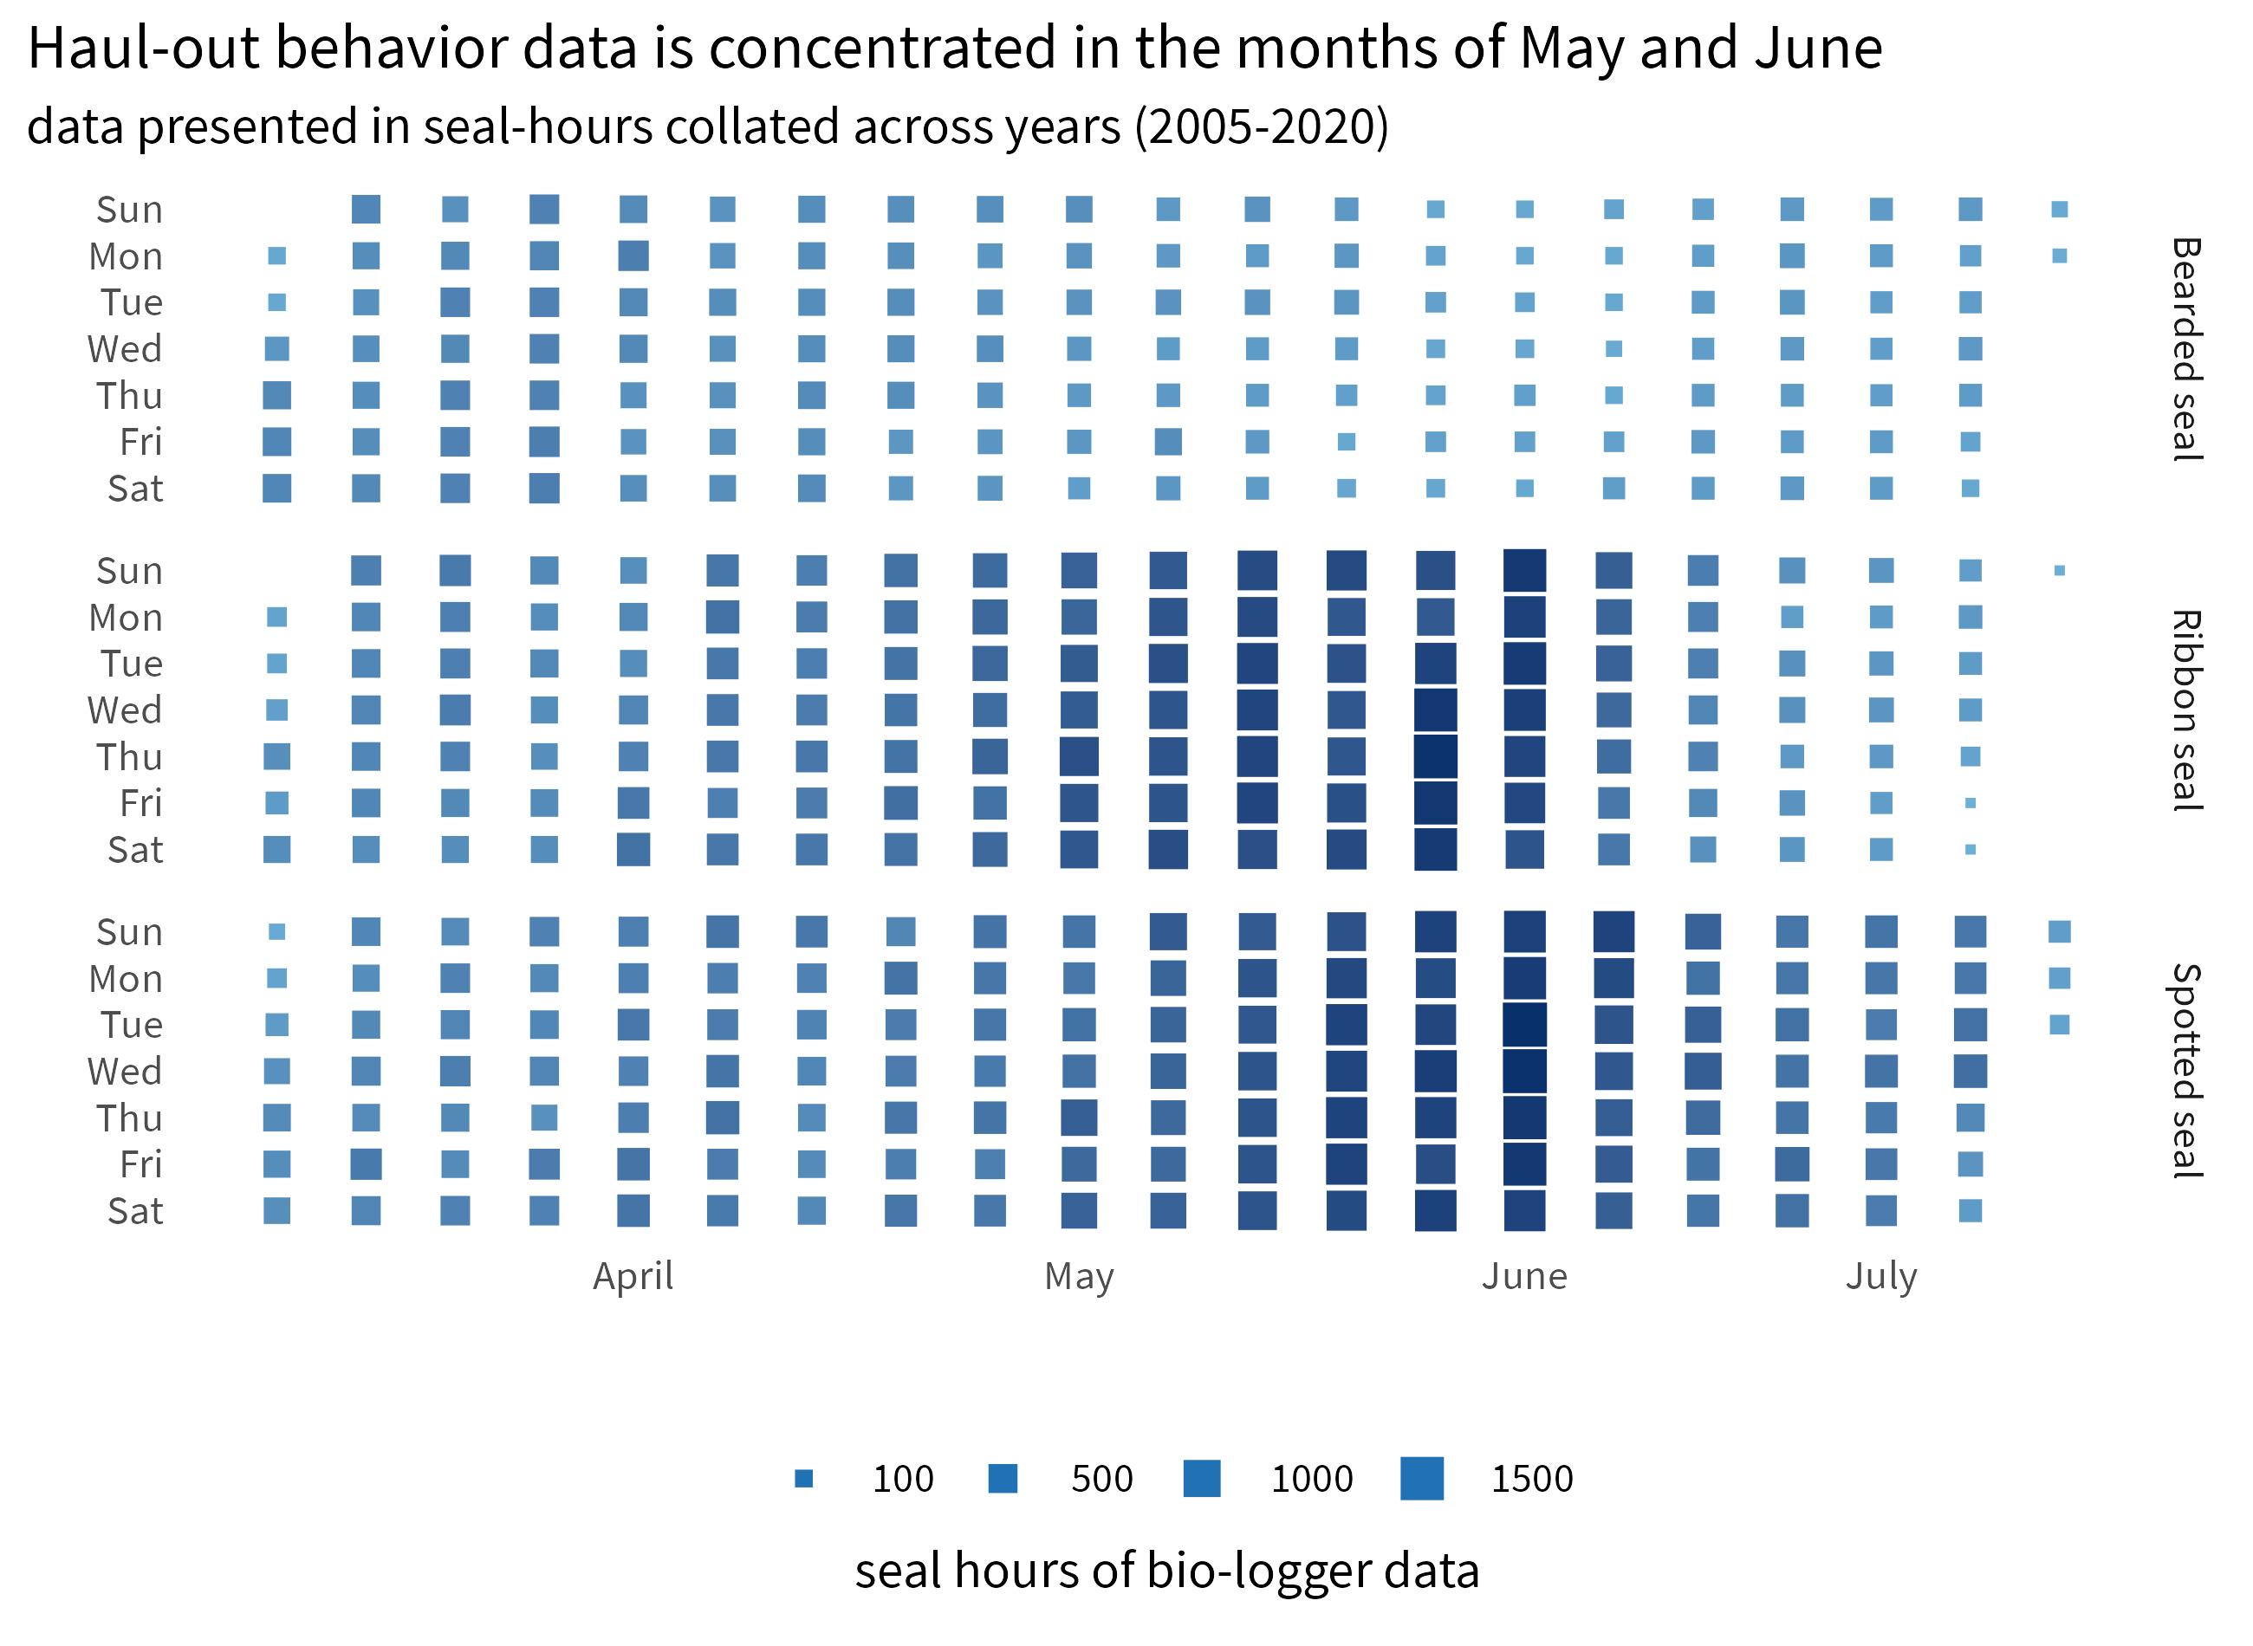

Figure : Distribution of haul-out behavior data from 1 March to 15 July for each species. The higher density of data from May and June coincides with peak molting when seals (and their attached bio-loggers) are more likely hauled out. Additionally, a majority of deployments started in April and May. Data were collated across all years between 2005 and 2020.

Haul-out behavior data was recorded and transmitted via the Argos satellite network as hourly percent-dry timelines. For each hour of a day, the wet/dry sensor was polled by the tag firmware every few seconds and a percent of the hour in a dry state was calculated (Figure ). Each data transmission message consisted of a complete 24-hour record. Tags were, generally, deployed and programmed in a manner to maximize data transmission during the spring pupping and molting period, however, not all days during the deployment were successfully transmitted. This is due to a variety of factors including satellite coverage, tag availability (i.e. tags mounted to the rear flipper are not available to the surface while the seal is at sea), tag performance, duty cycling, and extra-terrestrial interference.

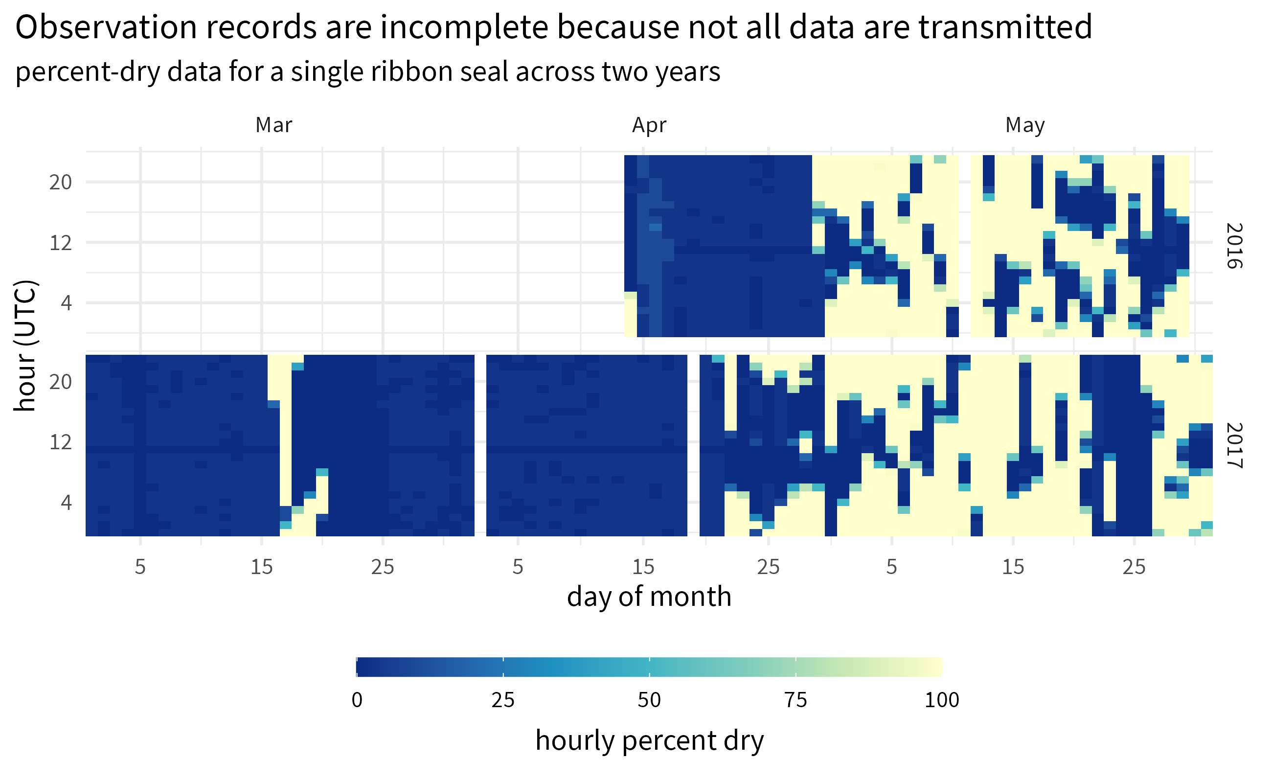

Figure : Haul-out behavior observations recorded by a bio-logger deployment on a ribbon seal over two years during the months of March, April, and May. Empty areas of the plot within a month represent missing data that were not successfully transmitted from the tag.

Of key interest in this study is the relationship between haul-out behavior and a variety of environmental covariates that vary with space and time. We explored the use of a movement model to predict locations at specific times. However, the sparse nature of data from some tags, especially those mounted to the rear flipper, resulted in poor modeling performance or convergence issues. For this study, we calculated a weighted average daily location where the inverse of the estimated Argos location error was used for the weight. Any days where haul-out observations were present without any location data were filled from the last calculated weighted average daily location, and any days where the location intersected with land were removed from the dataset. Figure shows the spatial distribution of determined locations and available haul-out behavior data for each species across the study area.

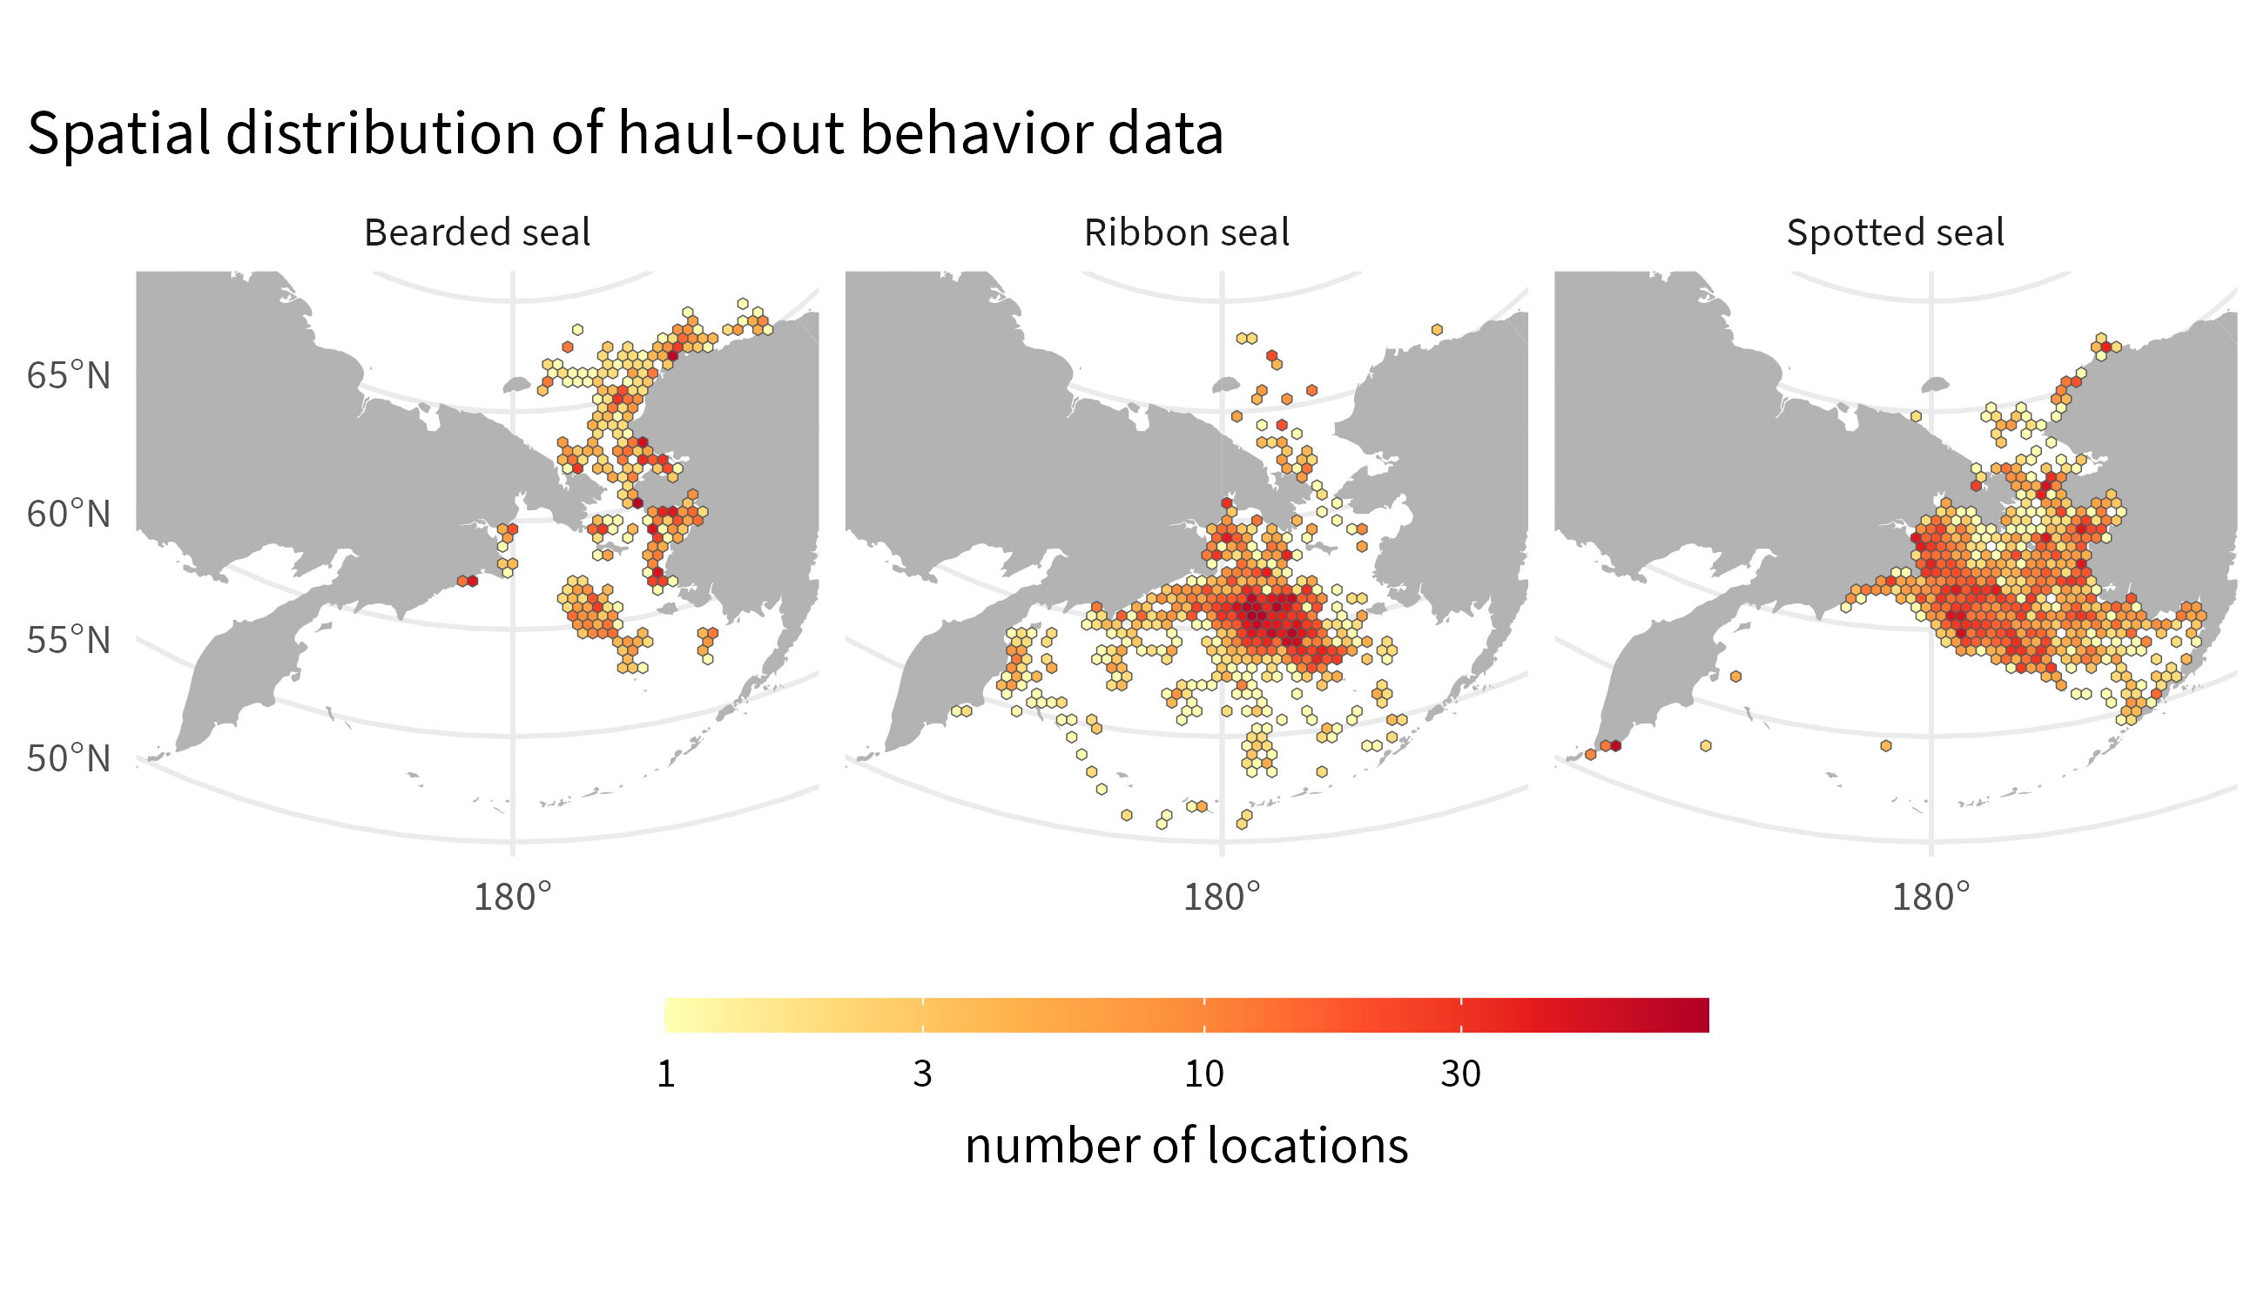

Figure : Spatial distribution of haul-out data during the months of March through July for each of the three species. Data were collated across all years between 2005 and 2020.

## Explanatory variables

In addition to sex and age class, we gathered additional variables that might help explain variation in haul-out probabilities. These included day-of-year (for seasonal effects) and local solar hour (for diurnal effects). Solar hour was calculated using the {solaR} package [20] within the R statistical environment [21] using the daily locations. We also compiled several meteorological variables shown to affect haul-out behavior in other Arctic pinnipeds [16,17,22]. In particular, we linked locations from satellite tags to key weather values from the North American Regional Reanalysis (NARR) model produced by the National Centers for Environmental Prediction [23]. The NARR model assimilates observational data to produce a long-term picture of weather over North America. Numerous weather variables are made available across the region 8 times daily. For this study, NARR weather values were subset to the extent of our study area over the Bering and Chukchi Seas at 3-hr intervals based on the native grid resolution of 32 km (1024 sq. km). The following meteorological variables were interpolated and assigned to seal locations using a bilinear method: 1) air temperature at 2m above the earth’s surface, 2) wind consisting of northerly and easterly vector components converted to wind speed using the Euclidean norm, 3) barometric pressure at sea level, and 4) precipitation (Table ).

Models for all species include the following effects: day-of-year, solar hour, temperature, wind speed, barometric pressure, precipitation, wind chill (represented by a *wind:temperature* interaction [17]), and day-of-year and time of day interactions to permit diurnal patterns to change throughout the year. Spotted and ribbon seal models included age-sex class and interactions between day-of-year and age-sex class, but we omitted these from bearded seal models due to poor representation of age-sex classes (Table ). Bearded seal models included a latitudinal effect (and an interaction with day-of-year), since bearded seals occupy a substantial range and we were interested in possible differences in the timing of haul-out behavior along a latitudinal gradient. We omitted the latitudinal effect from ribbon and spotted seal models since, during the spring, these species are most prevalent near the southern ice edge in the Bering Sea [19].

Notably missing from this list of explanatory variables is any spatial-temporal representation of sea ice concentration, area, or extent. This may seem counterintuitive when modeling the haul-out behavior of seal species with such a close association to sea ice; seals haul out in the presence of sea ice, and we could assess the local concentration of sea ice during these events (see [24]). However, a major focus of this study is to develop models applicable for aerial survey correction factors and using sea ice as a covariate would almost certainly bias haul-out predictions towards those seals that are on or near ice and therefore more likely to haul out. Since aerial surveys can only detect seals on ice, abundance estimates would be missing a correction for those seals that are away from ice (e.g., on foraging trips). Additionally, many of the bio-logger deployments used in this study were single attachments to the rear flipper of the seal and do not provide at-sea locations, limiting our ability to fully evaluate habitat preferences related to sea-ice. It should be noted that the aerial survey counts are modeled with sea-ice and other habitat parameters. So, any final abundance estimates that combine models of survey counts and our model for proportion of seals hauled out on ice do account for the strong association between these species and sea-ice in the Bering and Chukchi seas. Lastly, our study was limited to the spring season when seal haul-out tendencies are strongly influenced by pupping, nursing, breeding, and molt and these drivers are likely more influential than specific sea-ice concentration. Crawford et al [25] compared haul-out probability models for bearded seals and found those that only included season (and not sea-ice concentration) were the most parsimonious. For these reasons, we have elected not to use sea ice concentration as a predictor for haul-out probability; studies to evaluate habitat selection in relation to sea-ice parameters and other environmental covariates are in progress.

We explored whether the annual variation in maximum spring sea ice extent in the Bering Sea influences the seasonal peak of seal haul-out behavior. In particular, we used sea ice concentration data from the Nimbus-7 SMMR and DMSP SSM/I-SSMIS Passive Microwave Dataset, Version 1 [26] to calculate maximum sea ice extent. All sea ice concentration grid cells (25 km2) in the study area with greater than 15% concentration were summed to get the total sea ice extent for each day between 15 February and 15 July across all years. Maximum spring sea ice extent was simply the largest daily value for each year.

Table : Explanatory covariates used in analyses of binary haul-out records for ice-associated seals. Note that we also considered select interactions (see article text) between these primary covariates. For instance, wind chill was represented by the interaction *temperature:wind*.

| Covariate | Type | Source | Description |
| --- | --- | --- | --- |
| Age-sex class | Categorical | Field Assessment | young-of-the-year, subadult, adult male and adult female |
| Hour | Continuous; Fourier basis | Bio-logger | local solar hour using 6 variables of a Fourier-series basis |
| Day | Continuous | Bio-logger | linear, quadratic, and cubic effects of day-of-year |
| Precip | Continuous | NARR | convective precipitation (kg/m2) |
| Pressure | Continuous | NARR | atmospheric pressure at sea level (kPa) |
| Temp | Continuous | NARR | air temperatures at 2m above the earth’s surface |
| Wind | Continuous | NARR | northerly and easterly vector components for wind converted into a single wind speed via the Euclidean norm |
| Northing | Continuous | Bio-logger | latitude divided by the mean latitude across all locations (for bearded seals only) |

## Haul-out modeling

Haul-out records for seals are often characterized by multiple hours spent basking on ice alternating with long periods of foraging (Figure ). Commonly used statistical models for binary data (e.g. logistic regression) assume independence among responses, an assumption that is clearly violated if hourly responses are modeled. Any analysis that ignores temporal dependence in responses will thus have overstated precision [27].

To properly account for temporal dependence within a computationally tractable framework, we used generalized linear mixed pseudo-models (GLMPMs; [28]) to model variation in haul-out behavior as a function of (1) covariate predictors, (2) temporally autocorrelated random effects, and (3) individual random effects representing heterogeneity in individual behavior. We used the {glmmLDTS} package [28] to implement GLMPMs in the R programming environment [29]. We explored two different model formulations for our data, and owing to the large number of records, we fit separate models to bearded, ribbon, and spotted seal data sets. In our first model formulation, for each species, we fitted a year-independent model that predicted average haul-out behavior as a function of demographic, environmental, seasonal, and diurnal effects. Second, for ribbon and spotted seals (which had considerably more data than bearded seals), we fitted models that included all the effects from the first model, but also permitted annual variation in haul-out timing. This second class of models was used to examine whether haul-out patterns varied by year and to determine the annual timing of apparent peaks in haul-out behavior.

We followed Ver Hoef et al. [14] in using linear, quadratic, and cubic effects of day-of-year to represent seasonal changes in behavior. However, unlike previous models for harbor seals [30] and ice-associated seals [14], which treated hour-of-day as a 24-level categorical variable to capture diurnal cycles, we adopted a continuous formulation based on Fourier series that provides a flexible model while preserving the inherent circularity needed for time-of-day effects (i.e., hour 0 should be equal to hour 24). It also represents hour-of-day with 6 parameters, which is a considerable reduction when compared to a 24 parameter variable, especially when fitting models with interactions between hour-of-day and other variables (e.g., age-sex class, day-of-year). According to this approach, we used the following specification for hour-of-day effects:

$$H_{t}=α_{1}\text{cos}\left(\frac{πt}{4}\right)+α_{2}\text{sin}\left(\frac{πt}{4}\right)+α_{3}\text{cos}\left(\frac{πt}{6}\right)+α_{4}\text{sin}\left(\frac{πt}{6}\right)+α_{5}\text{cos}\left(\frac{πt}{12}\right)+α_{6}\text{sin}\left(\frac{πt}{12}\right)$$

where $H_{t}$ gives the effect for solar hour $t$ and $α_{i}$ are estimated parameters (regression coefficients).

For the second set of models examining inter-annual variation in sea ice use, we fitted models with year by day-of-year interactions. However, in this case we only included *year:day* and *year:day2*, omitting the main effects of year as well as *year:day3* interactions because models with the latter effects were numerically unstable. However, the modeled interactions were sufficient to allow shifts in haul-out distribution, as one can show mathematically that a simple horizontal shift in timing of haul-out distributions does not affect the main effects or cubic terms in a polynomial regression model.

A typical model fitting exercise would also include a model selection process. However, AIC (and similar criteria) is not suitable when using pseudo-likelihoods, because pseudo-data generated in the model fitting process [28] differ between models [31]. After fitting GLMPM models, we instead used “type III” $F$-tests to calculate $p$-values [28] to evaluate model performance and important terms. We also produced predictions of haul-out behavior as a function of influential predictors (e.g. solar hour, day-of-year, age-sex). Weather covariates for these predictions were based on daily or hourly smoothed weather covariate values across the study region. Such predictions were then used to develop haul-out probability surfaces, explore conditional effects of weather covariates, and determine annual peaks in haul-out activity. The timing of peak haul-out behavior was further used to regress against the annual maximum sea ice extent in the study region.

# Results

Models omitting year effects suggested that day-of-year, solar hour, age-sex class, temperature, and wind substantially influenced haul-out behavior of all three species, with $F$ tests producing $p$-values less than 0.05 for variables embodying these effects and/or their interactions. Haul-out probabilities typically increased throughout March and April, reaching a peak in May and early June before declining again. Diurnal patterns were present, with maximum haul-out behavior centered around local solar noon.

## Ribbon Seals

Ribbon seals show a pattern of gradually increasing haul-out probability in April that peaks in late May for subadults and in early June for adults (Figure ). The behavior is clearly centered around local solar noon and expands to other hours later in the season as seals enter their molting period. Subadults showed an earlier start and more intense haul-out activity in April and May. The young-of-the-year records begin after weaning and the model predictions demonstrate the ontogeny of in-water activities (e.g. diving, foraging) in May. Adult females have a more protracted haul-out season compared to males, and more time spent resting in June and July. The model suggests adult male ribbon seals complete their molt by the end of June. Lastly, for adults of both sexes there is some indication for a shift to a crepuscular haul-out pattern in late June and July.

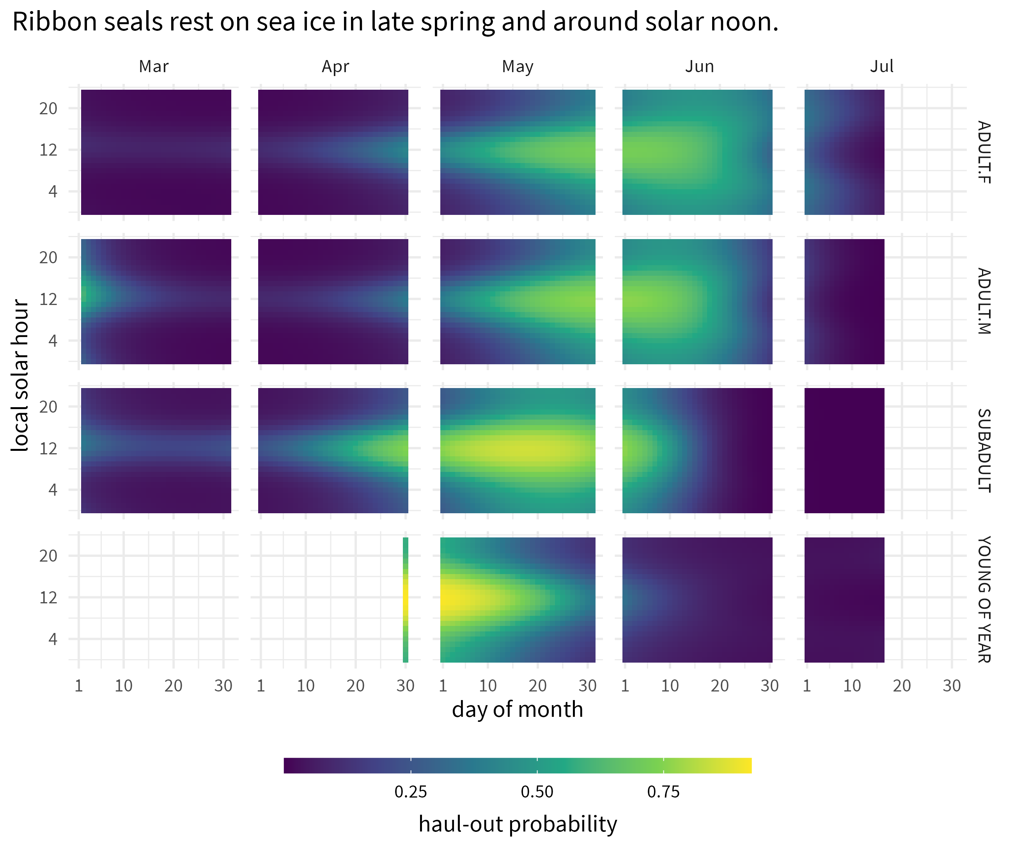

Figure : Predicted haul-out probability of ribbon seals from 1 March to 15 July for each age and sex class used in the model. Adult females are indicated by ‘ADULT.F’ and ‘ADULT.M’ indicates adult males. ‘SUBADULT’ and ‘YOUNG OF YEAR’ age classes include both sexes.

The haul-out probability for ribbon seals was strongly influenced by each of the weather covariates included within the model except precipitation. The impacts of temperature ( $F_{1,99593}$ = 15.688; $p$ = <0.001), wind ( $F_{1,99593}$ = 72.392; $p$ = <0.001), and barometric pressure ( $F_{1,99593}$ = 9.521; $p$ = 0.002) were especially noticeable as ribbon seals were less likely to haul out at higher winds and lower pressure values and more likely to be on the ice when temperatures were relatively warm. Wind chill ( $F_{1,99593}$ = 2.794; $p$ = 0.095) showed a moderately negative influence on haul-out probability.

Visualizing the marginal effect of each weather covariate on haul-out probability is difficult in this analysis because of the collinearity between covariates as well as the temporal variation in covariate values during the study period. The relationship of each weather covariate with haul-out probability, averaged over the other weather conditions, is more variable than simply showing model coefficients would imply. Figure ) presents the predicted haul-out probability of ribbon seals across the range of weather conditions encountered in the observed data. The collinearity and temporal variation are apparent in the visual patterns that emerge. By

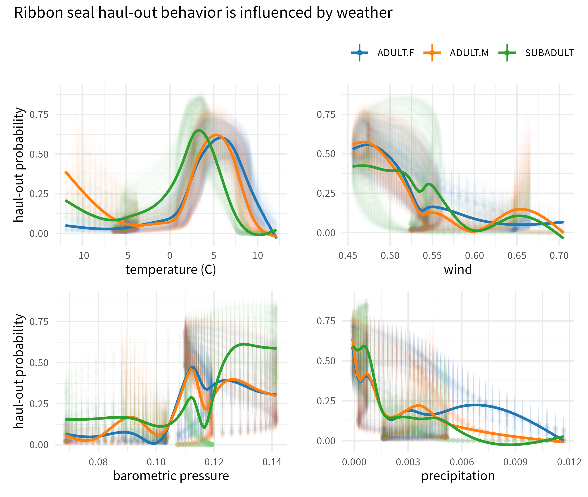

Figure : Variability in predicted haul-out probability of ribbon seals across the range of weather conditions encountered in the observed data. Transparent vertical lines represent the 95% confidence interval around the predicted haul-out probability. Solid lines are smoothed fits to the predictions and provided to better indicate the marginal effect.

## Spotted Seals

Compared to ribbon seals, spotted seals showed a longer spring haul-out season that is less intensely centered on solar noon (Figure ). Adults of both sexes spend considerable time in April and May resting on the ice. As with ribbon seals, the young-of-the-year records begin after weaning and the model predictions demonstrate the ontogeny of in-water activities (e.g. diving, foraging) in May.

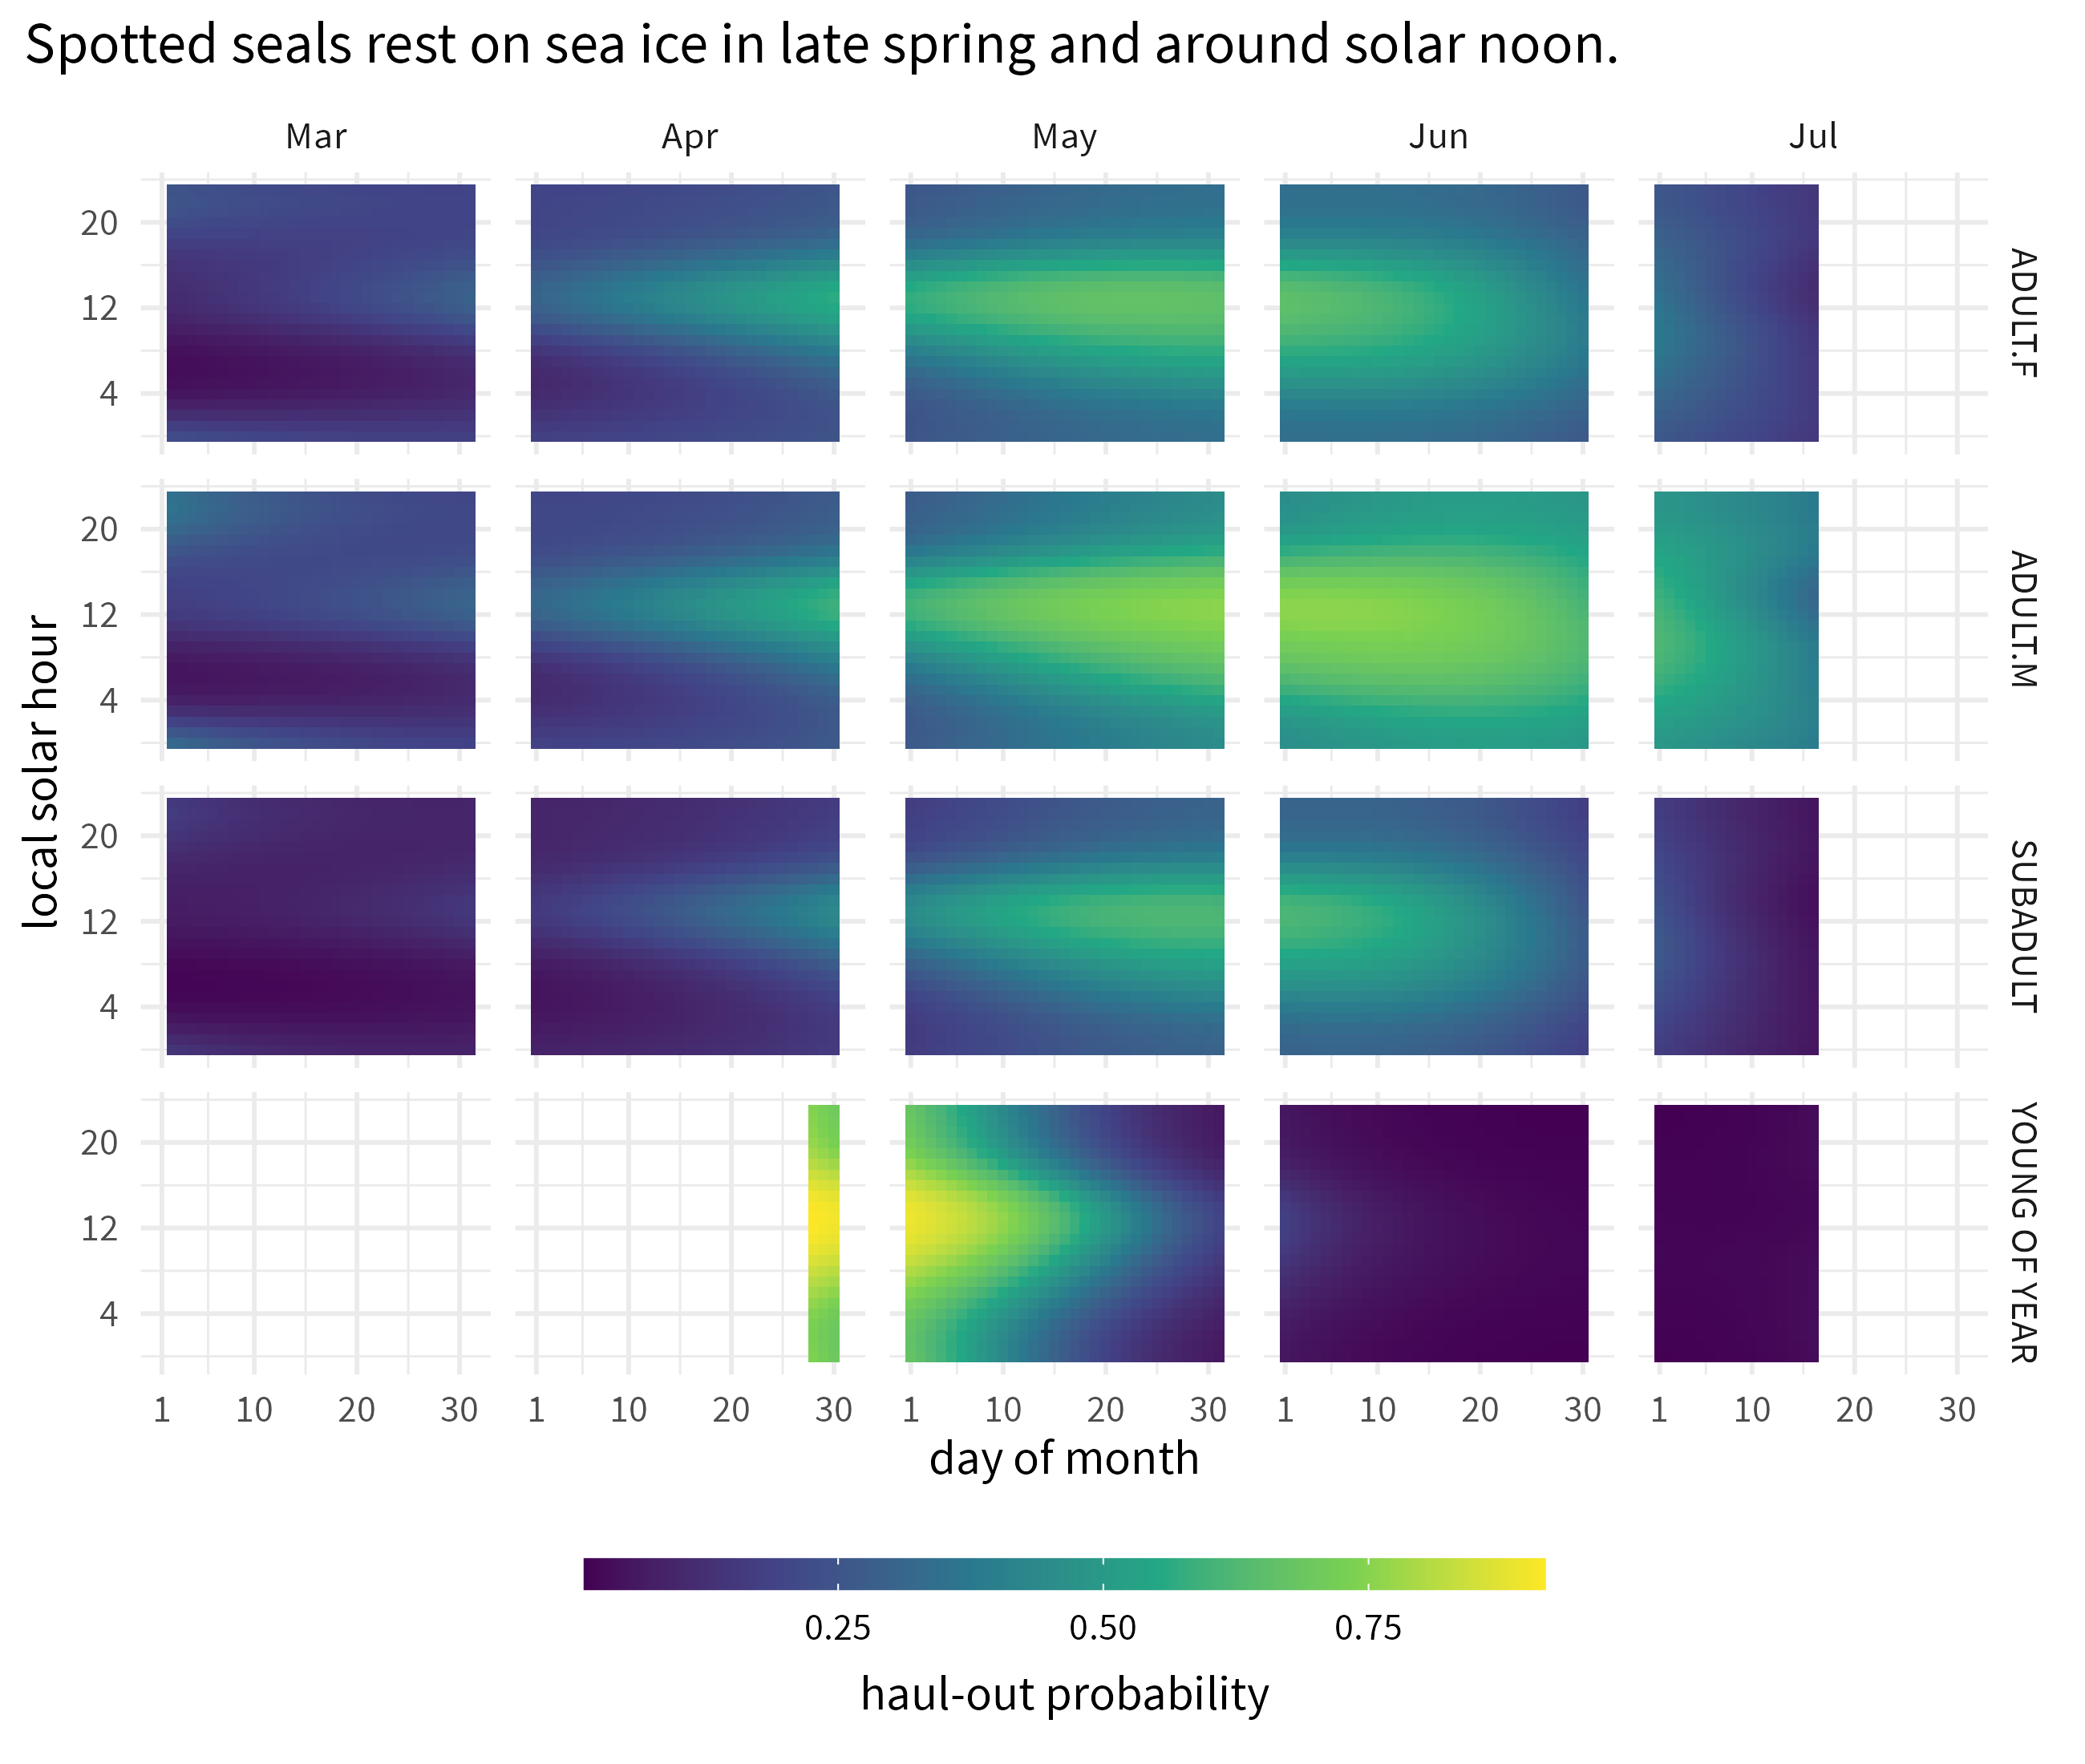

Figure : Predicted haul-out probability of spotted seals from 1 March to 15 July for each age and sex class used in the model. Adult females are indicated by ‘ADULT.F’ and ‘ADULT.M’ indicates adult males. ‘SUBADULT’ and ‘YOUNG OF YEAR’ age classes include both sexes.

Spotted seal haul-out behavior appears most strongly influenced by temperature ( $F_{1,108429}$ = 3.432; $p$ = 0.064) and wind ( $F_{1,108429}$ = 25.821; $p$ = <0.001) with barometric pressure having a moderate influence ( $F_{1,108429}$ = 5.05; $p$ = 0.025). Spotted seals were less likely to haul out at higher winds and more likely to be on the ice when temperatures were relatively warm. Wind chill (*temperature:wind*) and precipitation were not as influential as the other covariates. Differences in the magnitude of response between the age-sex classes are present and consistent across each of the weather covariates (Figure ).

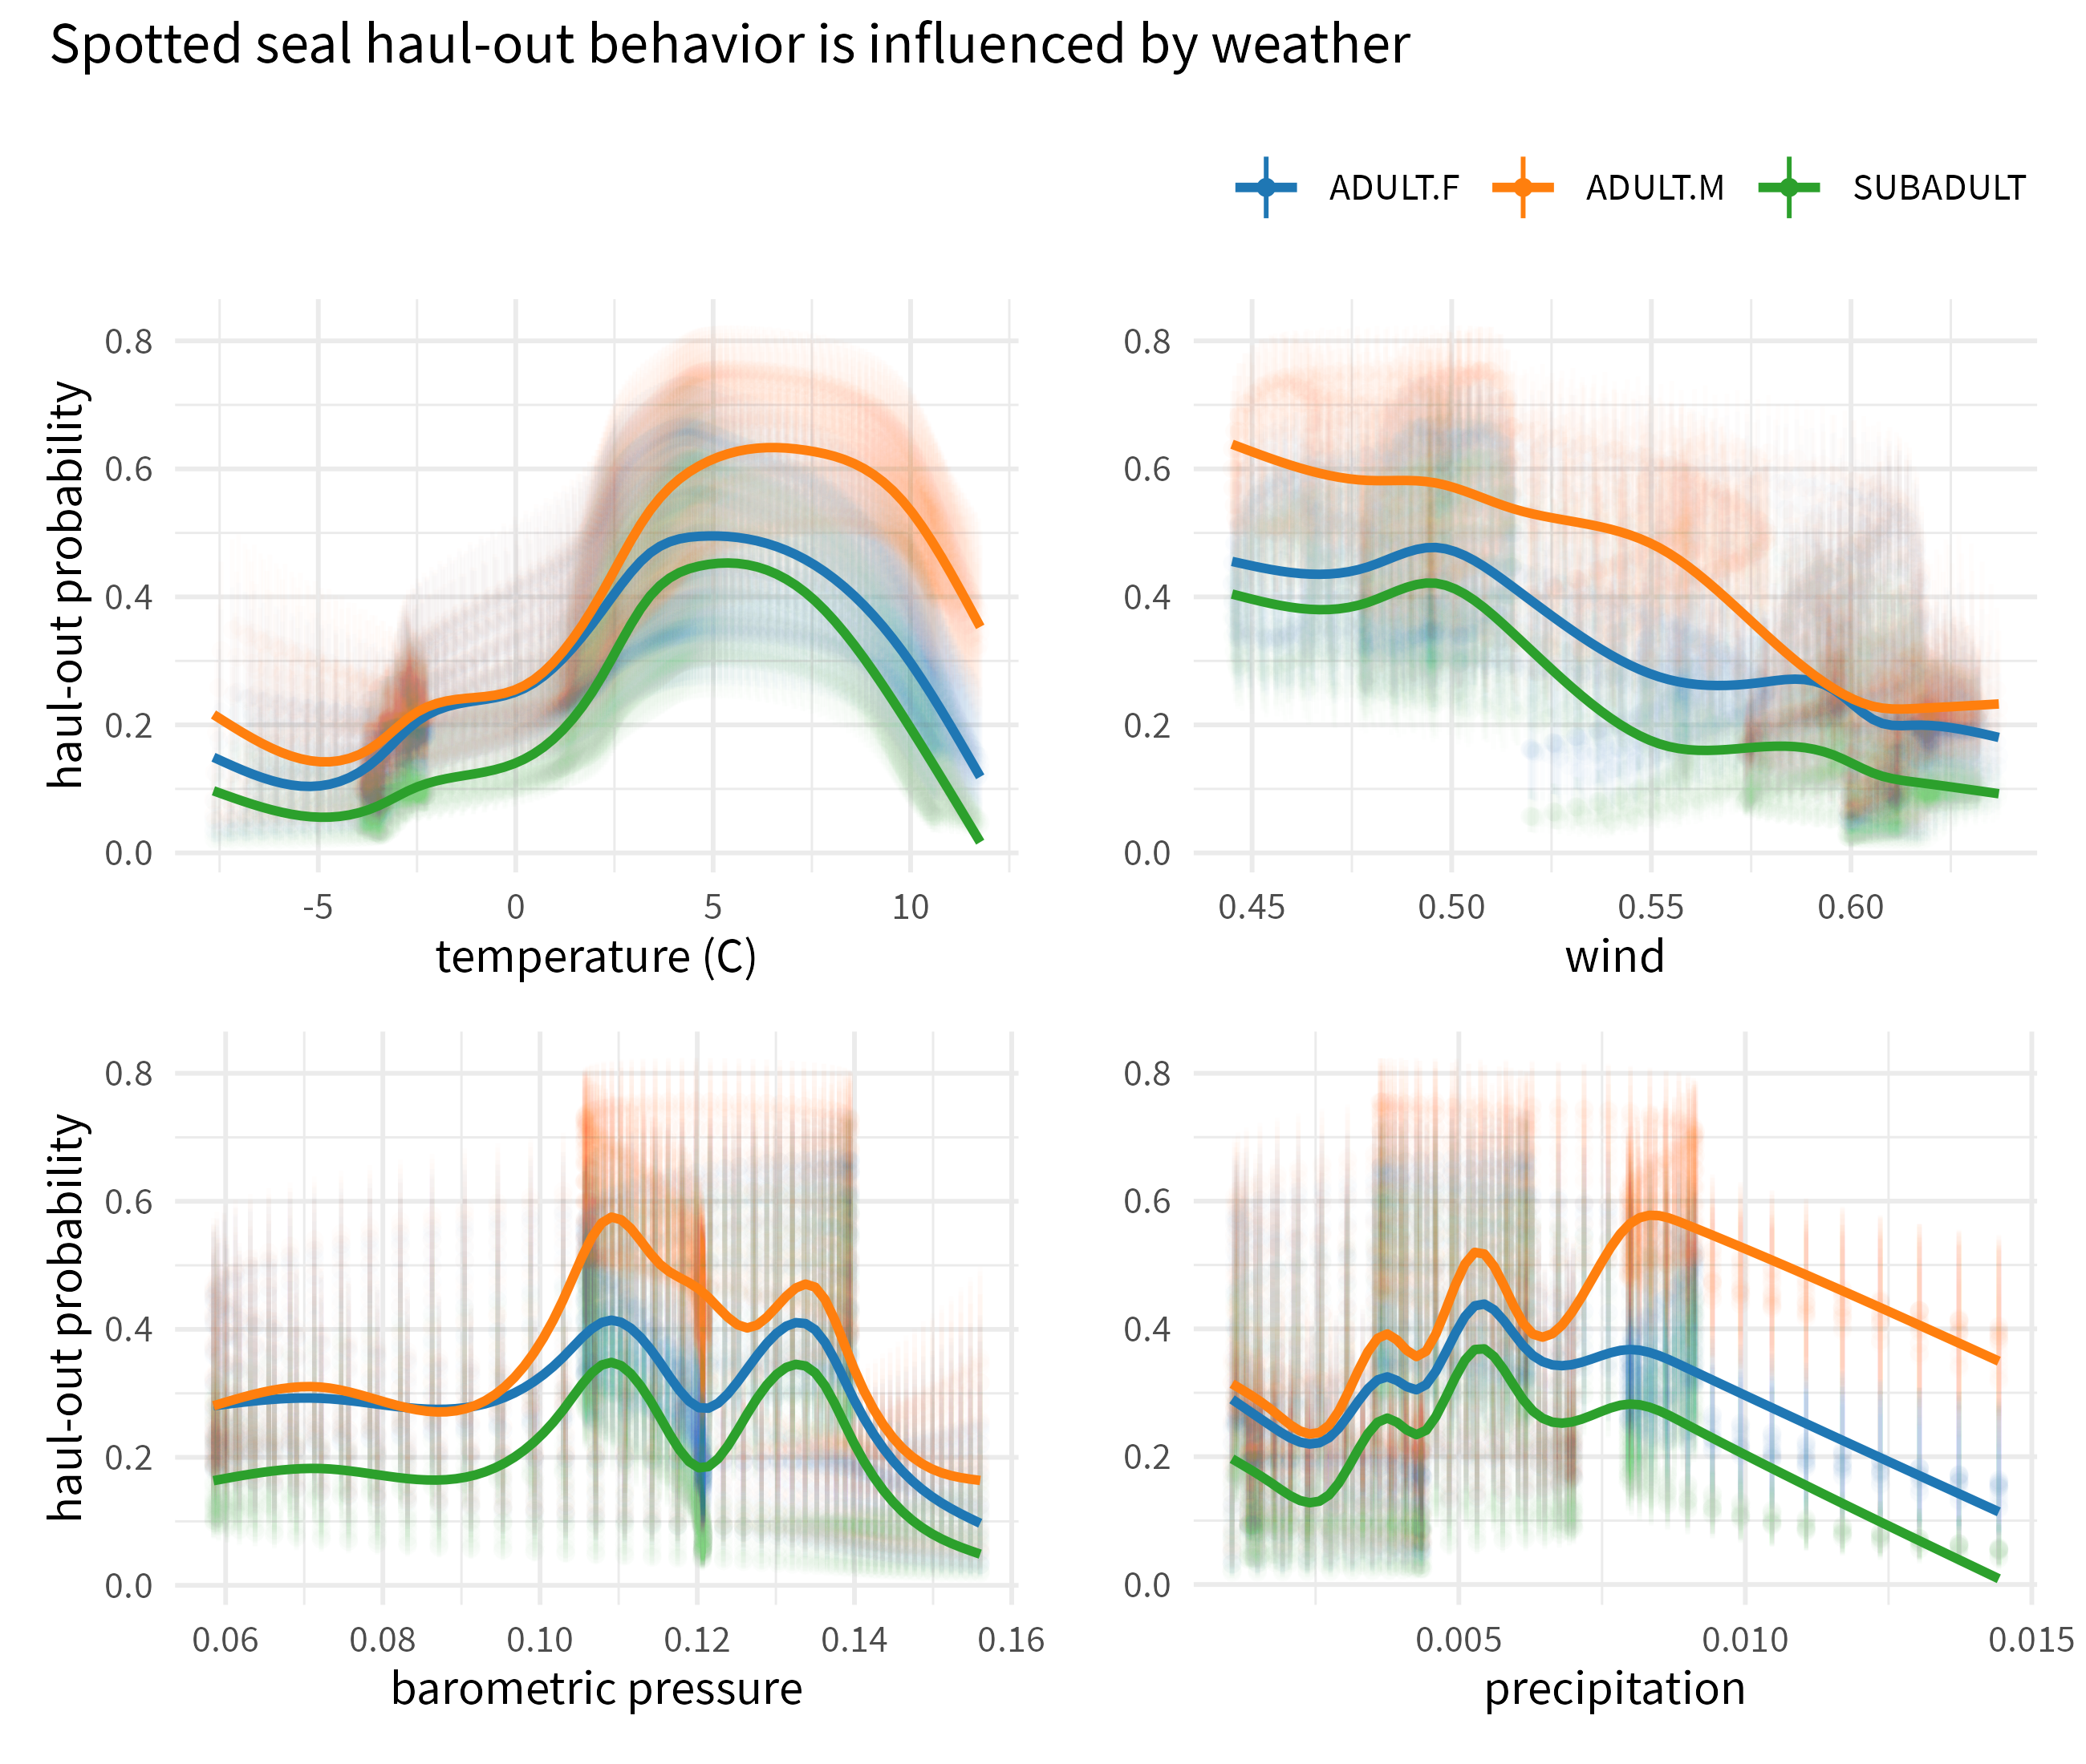

Figure : Variability in the predicted haul-out probability of spotted seals across the range of weather conditions encountered in the observed data. Transparent vertical lines represent the 95% confidence interval around the predicted haul-out probability. Solid lines are smoothed fits to the predictions and provided to better indicate the marginal effect.

## Bearded Seals

Age and sex class were not included in the model for bearded seals and, as such, results are shown for all ages. Unlike ribbon and spotted seals, bearded seals were predicted to have a bi-modal distribution of haul-out probability across the day (Figure ). In addition to a peak around local solar noon, the bearded seal model predicts additional haul-out activity around local midnight. The haul-out behavior is also more protracted throughout the spring season compared to ribbon and spotted seals.

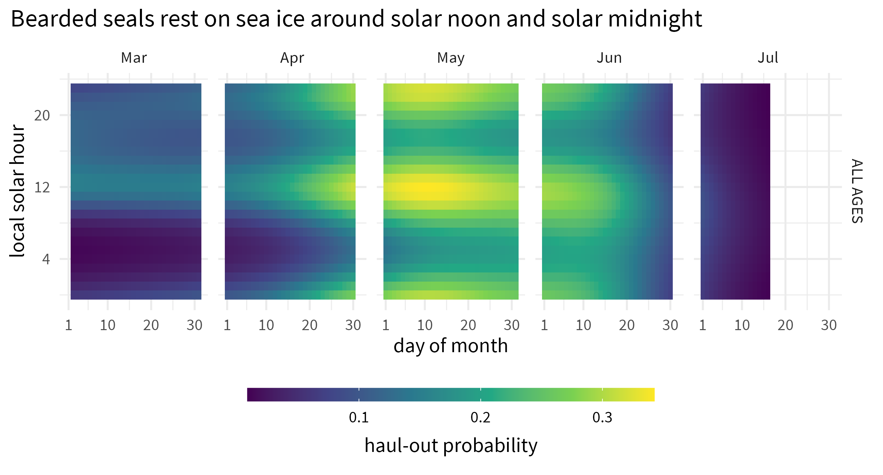

Figure : Predicted haul-out probability of bearded seals from 1 March to 15 July for all and sex classes.

Like ribbon and spotted seals, bearded seal haul-out probability appears most influenced by wind ( $F_{1,42302}$ = 185.426; $p$ = <0.001) and temperature ( $F_{1,42302}$ = 14.915; $p$ = <0.001). Additionally, wind chill was also a significant influence ( $F_{1,42302}$ = 13.58; $p$ = <0.001). Any influence of barometric pressure or precipitation is less apparent (Figure ).

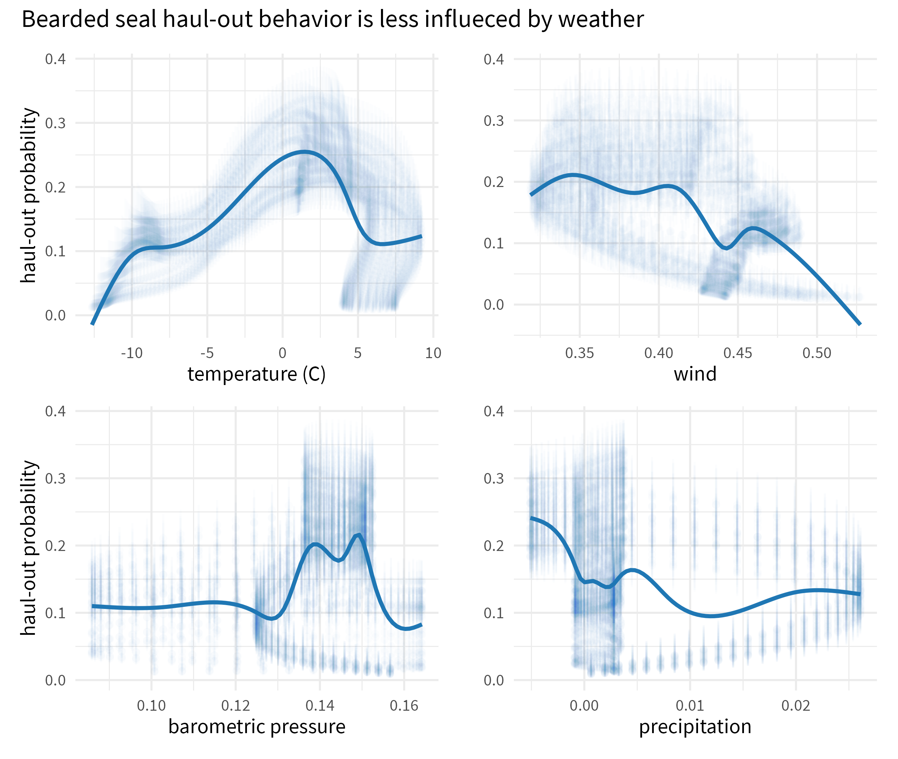

Figure : Variability in predicted haul-out probability of bearded seals across the range of weather conditions encountered in the observed data. Transparent vertical lines represent the 95% confidence interval around the predicted haul-out probability. Solid lines are smoothed fits to the predictions and provided to better indicate the marginal effect.

## Annual variation in haul-out

The second set of models that included annual variation in haul-out patterns uncovered significant contributions for linear and quadratic interactions between day and year in both ribbon seals (day $×$ year, $F_{10,99563}$ = 4.051; $p$ = <0.001; day2:year, = 4.582; $p$ = <0.001) and spotted seals (day $×$ year, $F_{14,108387}$ = 4.732; $p$ = <0.001; day2:year, = 4.848; $p$ = <0.001). Predicted distributions of haul-out activity were largely unimodal, but varied some among and within years with respect to the timing and magnitude of haul-out peaks (Figure ). It is important to note that predicted variation in annual haul-out patterns likely reflects both process error and sampling variability. While we did remove any years where only one deployment in a species + age-sex group was present, there are still some years where the pattern shown is informed by a small number of individuals that may not represent population level processes.

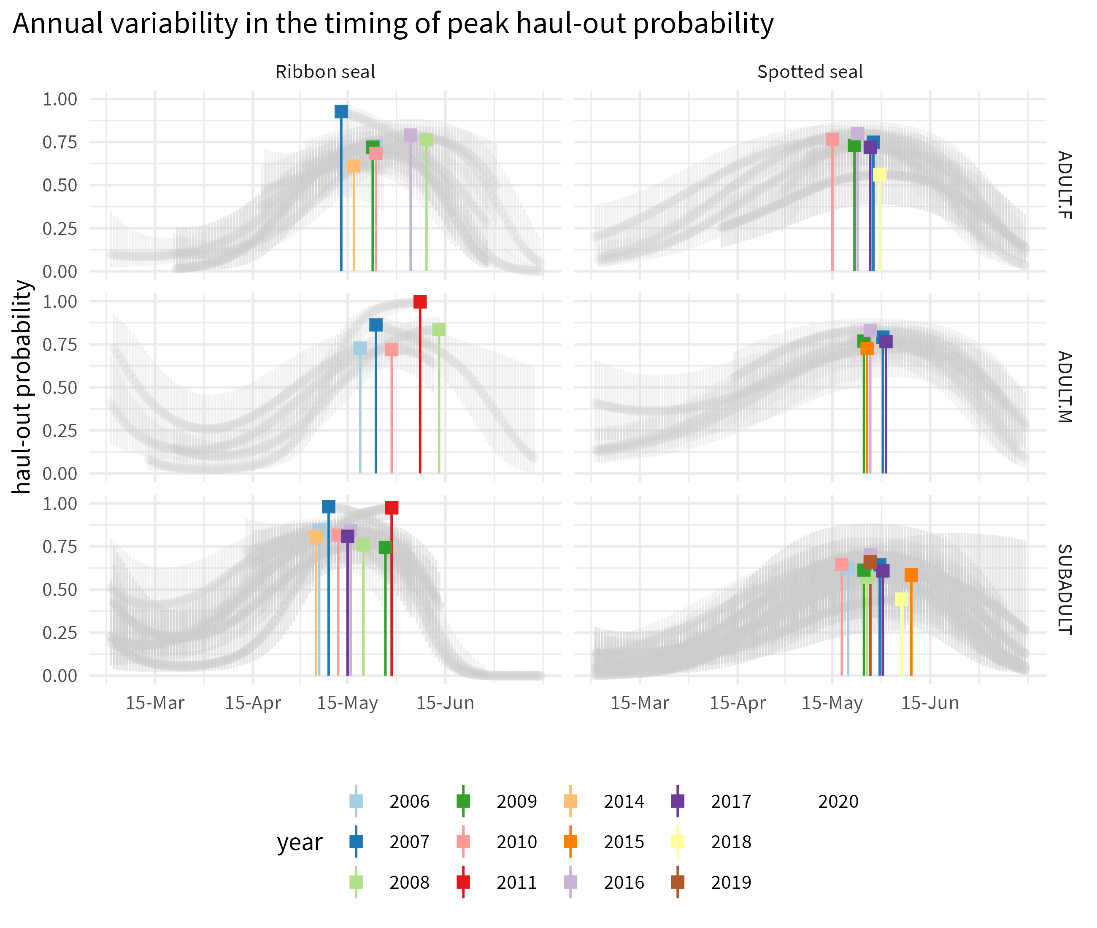

Figure : Annual variability in the timing of peak haul-out probability for ribbon and spotted seals across 10 years. Predictions are shown for local solar noon and under smoothed weather conditions. Only those groups (age-sex + year) that included observations from more than one seal are shown. Additionally, any groups where the underlying data started after 1 June or ended before 1 May are not included.

The timing of peak haul-out probability for ribbon and spotted seals appeared to have only a limited to no relationship with the amount of yearly maximum sea ice extent. Adult female and subadult spotted seals show a negative trend line, but there is no indication that the observed trend is meaningful (spotted seal adult female: $R^{2}$ = 0.767, $p$ = 0.022; spotted seal subadults: $R^{2}$ = 0.449, $p$ = 0.034). For ribbon seals and adult male spotted seals, $p$-values were substantially larger than 0.05 (ribbon seal adult females; $R^{2}$ = 0.035, $p$ = 0.689; ribbon seal adult males: $R^{2}$ = 0.116, $p$ = 0.575; ribbon seal subadults: $R^{2}$ = 0.013, $p$ = 0.773; spotted seals adult males: $R^{2}$ = 0.107, $p$ = 0.592).

# Discussion

In this paper, we modeled data from bio-logging sensors deployed on bearded, spotted, and ribbon seals to examine factors affecting haul-out behavior on sea ice in the Bering and Chukchi seas. Our analysis shows seals use sea ice progressively more through the spring, with peak use near mid-May to early June before declining again. This pattern aligns well with what has been previously documented and confirms our bio-logging deployments are likely capturing population-level behavioral patterns. Seals preferentially haul out on ice shortly after solar noon, which allows seals to maximize absorption of solar radiation [32]. Interestingly, bearded seals appear to have two peaks in haul-out activity across the day, one shortly after solar noon, and one centered near solar midnight. A similar bi-modal pattern has been seen in ringed seals [33] and suggests that bearded and ringed seals may be operating under different constraints than ribbon and spotted seals. Bearded and ringed seals are distributed across higher latitudes and the extended daylight hours may allow more flexibility in optimizing resting periods with foraging.

Unlike previous analyses of seal haul-out data (e.g. [28], [19]), we also investigated the influence of sex-age class on haul-out probabilities for all species except bearded seals because of low sample size. While both ribbon and spotted seals exhibited a unimodal diel haul-out pattern generally centered around local solar noon, there were key differences across species, age, and sex that match expectations given what we know of their ecological behavior. Spotted seals are known to form triads during the breeding season [34] where a female and dependent pup are accompanied on the ice by a suitor male. The male waits for the female to wean the pup and enter estrus, and fends off any other males that may be interested. Triad formation results in both males and females spending a large portion of the day hauled out on ice and a protracted spring haul-out season for both sexes. Because mating occurs in the water, females may also be less inclined to venture out for foraging trips while still nursing the pup. We see this reflected in the predicted haul-out behavior, with both males and females exhibiting a broad distribution of time out of the water throughout the solar day and the season. Ribbon seals are not known to form triads and our model predicts a progression of increased haul-out behavior with females starting earlier in the season than males. Notably, female ribbon seals spend a large portion of the day in the water during the pupping period, aligning with the hypothesis that ribbon seal females continue foraging while nursing. In the case of both ribbon and spotted seals, subadults are the first to begin consistent haul-out behavior and follow a typical phocid pattern where subadults molt first as they do not have any reproductive constraints.

We also investigated the influence of environmental covariates on haul-out probabilities, including wind speed, temperature, barometric pressure, precipitation, and wind chill. These have been investigated for walrus (e.g. Udevitz et al. [17]) and a few select studies of ice-associated seals [22]. Ribbon seals seemed to be the most influenced by weather, with wind, temperature, barometric pressure, and precipitation all being important components of the model. Spotted seals were most affected by wind and barometric pressures. And, for bearded seals, the model indicated wind and temperature had the greatest impact. In general, and as might be expected, seals were more likely to haul-out when daily temperatures were warmer, winds speeds were lower, barometric pressure was higher, and precipitation was lower. These weather conditions are likely most beneficial for energetic considerations and may also provide the best situation for predator detection. These results highlight the importance for haul-out behavior models (and subsequent calculations of availability during surveys) to incorporate weather covariates.

Our model uncovered annual deviations in the timing and magnitude of haul-out peaks for ribbon and spotted seals. The timing of peak haul-out activity appears to fall within a relatively narrow time window of 3-4 weeks in late May and early June. This remarkable level of consistency across 15 years is indicative of the adaptations these species have evolved to synchronize their key life history stages with favorable environmental conditions (e.g. availability of sea ice, increased oceanographic productivity, favorable weather conditions). Unfortunately, this may also be indicative of a limited range of plasticity as climatological conditions change. Additionally, while from an ecological perspective the haul-out behavior appears consistent, the interannual differences in timing and magnitude are large enough to have important ramifications on calculations of abundance and trend.

Previous attempts to estimate the abundance of phocid seals from aerial survey data in the Bering and Chukchi Seas (e.g. [13], [19], [14]) have used estimated haul-out probabilities to correct for the proportion of animals that are in the water and thus unavailable to be counted during aerial surveys. Although several of these studies allowed haul-out probabilities to vary by day-of-year and time-of-day, previous correction factors have not accounted for variability between years, different weather conditions, and the age-sex class of the sample. In this paper, we have shown that there can be considerable differences in the number of seals hauled out on ice based on these factors. We recommend that future abundance analyses employ correction factors that account for these factors. For instance, it is relatively straightforward to obtain weather reanalysis products for times and locations that are surveyed and to construct a relevant correction factor based on predictions of GLMPMs. The most challenging element in developing availability correction factors is with annual variability. It can be difficult to get a sufficient sample size to estimate year-specific correction factors, particularly because research teams would likely need to tag seals and conduct aerial surveys concurrently which requires considerably more personnel and money. One possible suggestion is to estimate a “shift” parameter within models for aerial survey counts that allow the peak of haul-out distributions to be adjusted earlier or later in the year based on the frequency of counts observed over time. Regardless, researchers should anticipate there being some unmodeled heterogeneity in availability probability present in abundance estimates obtained from aerial surveys. This may make trend detection difficult, as one will not know if moderate differences in abundance estimates are attributable to changes in abundance or changes in haul-out frequencies.

Predictions of absolute haul-out probability in this paper were somewhat different than those previously reported for these species, especially for bearded seals. For instance, Ver Hoef et al. [14)] and Conn et al. [19] used haul-out correction factors with maximums of 0.66 for bearded seals, 0.62 for ribbon seals, and 0.54 for spotted seals, where maximums corresponded to times near solar noon in mid-late May. Applying models that ignore age, sex, and year effects, these probabilities were 0.38, 0.72, and 0.60, respectively, under the current analysis framework. Our current estimates reflect increased sample sizes in terms of number of animals, but also improvements to the way data were prepared prior to analysis.

We focused this paper on haul-out behavior of bearded, ribbon, and spotted seals. Ringed seals are also present in the Bering and Chukchi Seas but exhibit qualitatively different haul-out behavior. For instance, many ringed seals build subnivean layers in the snow on top of the sea ice, which they frequently inhabit before snow melt causes their lairs to collapse [36]. Thus, the wet-dry sensor on a satellite tag could indicate that an animal is hauled out, but it could still be unavailable to be detected because it is in a lair. We hope to address availability of ringed seals using data from satellite tags, replicate survey tracks, and auxiliary information about snow depth and timing of melt in a future study.

# Author Contributions

**Josh M. London**: investigation, conceptualization, methodology, formal analysis, validation, software, writing: original draft, writing: review and editing, visualization, and data curation

**Paul B. Conn**: conceptualization, methodology, formal analysis, software, validation, writing: original draft, writing: review and editing

**Stacie K. Hardy**: investigation, data curation, methodology, validation, writing: review and editing

**Erin L. Richmond**: data curation, investigation, methodology, validation, writing: review and editing

**Jay M. Ver Hoef**: conceptualization, methodology, software, writing: review and editing

**Irina S. Trukhanova**: conceptualization, writing: review and editing

**Michael F. Cameron**: investigation, project administration, writing: review and editing

**Peter L. Boveng**: investigation, conceptualization, supervision, project administration, writing: review and editing

# Data Availability

Data and code will be available as a complete research compendium on GitHub and major versions archived at Zenodo. Original data sources for telemetry are archived at the United States Animal Telemetry Network.

# Acknowledgements

We recognize that the species and ecosystems studied in this paper are within the traditional range of the Inpuiaq and Yupik people. And, we would like to acknowledge and thank them as the original stewards of these ecosystems. The deployment of bio-logging devices used in this study were often done in collaboration with Alaska Native communities. We would like to especially acknowledge the communities of Kotzebue, Utqiagvik, and Ulguniq and the following individuals: James Adams, Jeff Barger, David Barr, Wendell Booth, Cyrus Harris, Nereus ‘Doc’ Harris, Grover Harris, Lee Harris, Tom Jones, Frank Garfield, Brenda Goodwin, Henry Goodwin, John Goodwin, Pearl Goodwin, Willie Goodwin, Brett Kirk, Noah Naylor, Virgil Naylor Jr., Virgil Naylor Sr., Dan Savetilik, Allen Stone, and Randy Toshavik from Kotzebue, Alaska; Billy Adams, Mary-Ellen Ahmaogak, James Aiken, Tim Aiken, Sarah Coburn, Jason Herreman, Howard Kittick, Gilbert Leavitt, Isaac Leavitt, J.R. Leavitt, Enoch Oktollik, Shawn Oktollik, Stacey Osborn, Fred Rexford, Chuck Schaeffer, Ross Schaeffer, Bob Shears, and Joe Skin from the North Slope Borough, Alaska;

We are grateful for the assistance in catching and sampling seals by James Bailey, Michelle Barbieri, John Bengtson, Gavin Brady, Vladamir Burkanov, Cynthia Christman, Shawn Dahle, Rob Delong, Stacy DiRocco, Deb Fauquier, Shannon Fitzgerald, Kathy Frost, Scott Gende, Tracey Goldstein, Jeff Harris, Markus Horning, John Jansen, Shawn Johnson, Charles Littnan, Lloyd Lowry, Erin Moreland, Lorrie Rea, Gay Sheffield, Brent Stewart, and Dave Withrow. We also appreciate the commitment to science and safety by all officers and crew of the NOAA Ship Oscar Dyson, the NOAA Ship MacArthur II, and the RV Thomas G. Thompson.

Telemetry data from the Alaska Department of Fish and Game and the North Slope Borough Department of Wildlife Management were important contributions to the findings presented here. Both agencies collaborate closely with Alaska Native communities and the contributions of local hunters to the successful capture, deployment, and understanding of seal ecology are invaluable. Deployments in the western Bering Sea and Sea of Okhotsk were done in collaboration with Russian colleagues and North Pacific Wildlife.

The findings and conclusions in the paper are those of the author(s) and do not necessarily represent the views of the National Marine Fisheries Service, NOAA. Any use of trade, product, or firm names does not imply an endorsement by the U.S. Government. Funding for this study was provided by the U.S. National Oceanic and Atmospheric Administration. The field work was conducted under the authority of Marine Mammal Protection Act Research Permits Nos. 782-1676, 782-1765, 15126, and 19309 issued by the National Marine Fisheries Service, and Letters of Assurance of Compliance with Animal Welfare Act regulations, Nos. A/NW 2010-3 and A/NW 2016-1 from the Alaska Fisheries Science Center/Northwest Fisheries Science Center Institutional Animal Care and Use Committee.

# References

1. Kwok R. 2018 Arctic sea ice thickness, volume, and multiyear ice coverage: losses and coupled variability (1958–2018). *Environ. Res. Lett.* **13**, 105005. (doi:[10.1088/1748-9326/aae3ec](https://doi.org/10.1088/1748-9326/aae3ec))

2. Meier WN *et al.* 2014 Arctic sea ice in transformation: A review of recent observed changes and impacts on biology and human activity. *Reviews of Geophysics* **52**, 185–217.

3. Wang M, Yang Q, Overland J, Stabeno P. 2017 Sea-ice cover timing in the Pacific Arctic: The present and projections to mid-century by selected CMIP5 models. *Deep Sea Research Part II: Topical Studies in Oceanography* (doi:[10.1016/j.dsr2.2017.11.017](https://doi.org/10.1016/j.dsr2.2017.11.017))

4. Huntington HP *et al.* 2020 Evidence suggests potential transformation of the Pacific Arctic ecosystem is underway. *Nature Climate Change* (doi:[10.1038/s41558-020-0695-2](https://doi.org/10.1038/s41558-020-0695-2))

5. Boveng PL, Bengtson JL, Buckley TW, Cameron MF, Dahle SP, Kelly BP, Megrey BA, Overland JE, Williamson NJ. 2009 Status review of the spotted seal (Phoca largha).

6. Boveng PL *et al.* 2013 Status review of the ribbon seal (Histriophoca fasciata).

7. Cameron MF *et al.* 2010 Status review of the bearded seal (Erignathus barbatus).

8. Kelly BP *et al.* 2010 Status review of the ringed seal (Phoca hispida).

9. Burns JJ. 1981 Ribbon seal (*Phoca fasciata*).

10. Burns JJ. 2009 Harbor Seal and Spotted Seal (*Phoca vitulina and P. largha*). In *Encyclopedia of Marine Mammals* (eds William F. Perrin, Bernd Würsig, J. G. M. Thewissen), pp. 533–542. New York, NY: Academic Press.

11. Bengtson JL, Cameron MF. 2004 Seasonal haulout patterns of crabeater seals (Lobodon carcinophaga). *Polar Biology* **27**, 344–349.

12. Von Duyke AL, Douglas DC, Herreman JK, Crawford JA. 2020 Ringed seal (*Pusa hispida*) seasonal movements, diving, and haul-out behavior in the Beaufort, Chukchi, and Bering Seas (2011–2017). *Ecology and Evolution* **00**, 1–22. (doi:[10.1002/ece3.6302](https://doi.org/10.1002/ece3.6302))

13. Bengtson JL, Hiruki-Raring LM, Simpkins MA, Boveng PL. 2005 Ringed and bearded seal densities in the eastern Chukchi Sea, 1999–2000. *Polar Biology* **28**, 833–845.

14. Ver Hoef JM, Cameron MF, Boveng PL, London JM, Moreland EE. 2014 A spatial hierarchical model for abundance of three ice-associated seal species in the eastern Bering Sea. *Statistical Methodology* **17**, 46–66. (doi:[10.1016/j.stamet.2013.03.001](https://doi.org/10.1016/j.stamet.2013.03.001))

15. Olnes J, Crawford J, Citta JJ, Druckenmiller ML, Von Duyke AL, Quakenbush L. 2020 Movement, diving, and haul-out behaviors of juvenile bearded seals in the Bering, Chukchi and Beaufort seas, 2014–2018. *Polar Biology* (doi:[10.1007/s00300-020-02710-6](https://doi.org/10.1007/s00300-020-02710-6))

16. Reder S, Lydersen C, Arnold W, Kovacs KM. 2003 Haulout behaviour of High Arctic harbour seals (Phoca vitulina vitulina) in Svalbard, Norway. *Polar Biol* **27**, 6–16. (doi:[10.1007/s00300-003-0557-1](https://doi.org/10.1007/s00300-003-0557-1))

17. Udevitz MS, Jay CV, Fischbach AS, Garlich-Miller JL. 2009 Modeling haul-out behavior of walruses in Bering Sea ice. *Can. J. Zool.* **87**, 1111–1128. (doi:[10.1139/Z09-098](https://doi.org/10.1139/Z09-098))

18. Southwell C, Paxton CGM, Borchers D, Boveng P, Rogers T, de la Mare WK. 2008 Uncommon or cryptic? Challenges in estimating leopard seal abundance by conventional but state-of-the-art methods. *Deep-Sea Research I* **55**, 519–531. (doi:[DOI 10.1016/j.dsr.2008.01.005](https://doi.org/DOI 10.1016/j.dsr.2008.01.005))

19. Conn Paul B, Ver Hoef Jay M, McClintock Brett T, Moreland Erin E, London Josh M, Cameron Michael F, Dahle Shawn P, Boveng Peter L. 2014 Estimating multispecies abundance using automated detection systems: ice-associated seals in the Bering Sea. *Methods in Ecology and Evolution* **5**, 1280–1293. (doi:[10.1111/2041-210X.12127](https://doi.org/10.1111/2041-210X.12127))

20. Perpiñán O. 2012 solaR: Solar Radiation and Photovoltaic Systems with R. *Journal of Statistical Software* **50**, 1–32.

21. R Core Team. 2019 *R: A Language and Environment for Statistical Computing*. Vienna, Austria: R Foundation for Statistical Computing. See <https://www.R-project.org/>.

22. Perry EA, Stenson GB, Buren AD. 2017 Attendance and nursing patterns of harp seals in the harsh environment of the northwest Atlantic. *Polar Biol* **40**, 151–160. (doi:[10.1007/s00300-016-1938-6](https://doi.org/10.1007/s00300-016-1938-6))

23. Mesinger F *et al.* 2006 North American Regional Reanalysis. *Bull. Amer. Meteor. Soc.* **87**, 343–360. (doi:[10.1175/BAMS-87-3-343](https://doi.org/10.1175/BAMS-87-3-343))

24. Olnes J, Crawford J, Citta JJ, Druckenmiller ML, Von Duyke AL, Quakenbush L. 2020 Movement, diving, and haul-out behaviors of juvenile bearded seals in the Bering, Chukchi and Beaufort seas, 2014–2018. *Polar Biology* (doi:[10.1007/s00300-020-02710-6](https://doi.org/10.1007/s00300-020-02710-6))

25. Crawford JA, Frost KJ, Quakenbush LT, Whiting A. 2019 Seasonal and diel differences in dive and haul-out behavior of adult and subadult ringed seals (*Pusa hispida*) in the Bering and Chukchi seas. *Polar Biology* **42**, 65–80. (doi:[10.1007/s00300-018-2399-x](https://doi.org/10.1007/s00300-018-2399-x))

26. Cavalieri D. 1996 Sea Ice Concentrations from Nimbus-7 SMMR and DMSP SSM/I-SSMIS Passive Microwave Data, Version 1. (doi:[10.5067/8gq8lzqvl0vl](https://doi.org/10.5067/8gq8lzqvl0vl))

27. Betts MG, Diamond AW, Forbes GJ, Villard M-A, Gunn JS. 2006 The importance of spatial autocorrelation, extent and resolution in predicting forest bird occurrence. *Ecological Modelling* **191**, 197–224. (doi:[10.1016/j.ecolmodel.2005.04.027](https://doi.org/10.1016/j.ecolmodel.2005.04.027))

28. Ver Hoef JM, London JM, Boveng PL. 2010 Fast computing of some generalized linear mixed pseudo-models with temporal autocorrelation. *Comput Stat* **25**, 39–55. (doi:[10.1007/s00180-009-0160-1](https://doi.org/10.1007/s00180-009-0160-1))

29. R Core Team. 2021 R: A language and environment for statistical computing.

30. London JM, Ver Hoef JM, Jeffries SJ, Lance MM, Boveng PL. 2012 Haul-out behavior of harbor seals (*Phoca vitulina*) in Hood Canal, Washington. *PLoS ONE* **7**, e38180. (doi:[10.1371/journal.pone.0038180](https://doi.org/10.1371/journal.pone.0038180))

31. Ten Eyck P, Cavanaugh JE. 2017 An Alternate Approach to Pseudo-Likelihood Model Selection in the Generalized Linear Mixed Modeling Framework. *Sankhya B* **80**, 98–122. (doi:[10.1007/s13571-017-0130-5](https://doi.org/10.1007/s13571-017-0130-5))

32. Feltz ET, Fay FH. 1966 Thermal requirements in vitro of epidermal cells from seals. *Cryobiology* **3**, 261–264.

33. Von Duyke AL, Douglas DC, Herreman JK, Crawford JA. 2020 Ringed seal (*Pusa hispida*) seasonal movements, diving, and haul-out behavior in the Beaufort, Chukchi, and Bering Seas (2011–2017). *Ecology and Evolution* **00**, 1–22. (doi:[10.1002/ece3.6302](https://doi.org/10.1002/ece3.6302))

34. McClintock BT, Moreland EE, London JM, Dahle SP, Brady GM, Richmond EL, Yano KM, Boveng PL. 2015 Quantitative assessment of species identification in aerial transect surveys for ice-associated seals. *Marine Mammal Science* **21**, 1057–1076.

35. Hamilton CD, Kovacs KM, Ims RA, Lydersen C. 2018 Haul-out behaviour of Arctic ringed seals (Pusa hispida): inter-annual patterns and impacts of current environmental change. *Polar Biology* **41**, 1063–1082. (doi:[10.1007/s00300-018-2260-2](https://doi.org/10.1007/s00300-018-2260-2))

36. Kelly BP, Quakenbush LT. 1990 Spatiotemporal use of lairs by ringed seals (*Phoca hispida*). *Canadian Journal of Zoology* **68**, 2503–2512.